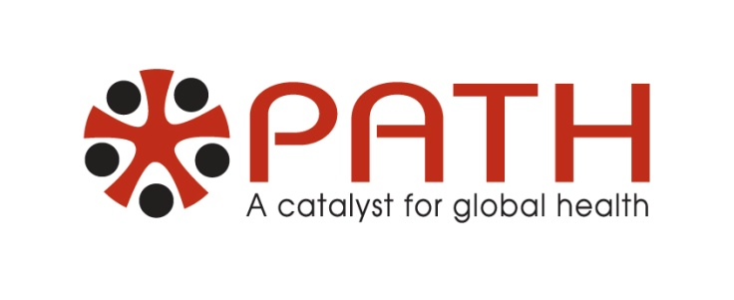

**Jordan Lane, Development Coordinator at PATH, will describe their ongoing work in Africa, China, India and other parts of the world where major health challenges exist. He will tell us about treatment programs and technologies they’ve developed and used successfully, and how they’ve achieved acceptance in the cultures where they work.**

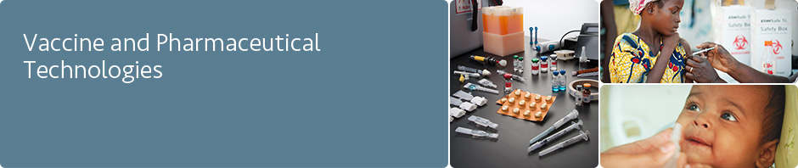

# 

Last year, by addressing the urgent health needs of the world’s most vulnerable populations, PATH’s work improved the lives of more than 205 million people in more than 70 countries. This included:

1. Solutions for emerging and epidemic diseases (HIV/AIDS, influenza, malaria, tuberculosis;

2. The development and delivery of lifesaving vaccines;

3. Safer childbirth and healthier mothers and children;

4. Health technologies designed for the needs and limitations of low-resource settings;

5. Better information, choices, and technologies for reproductive health, especially for vulnerable, low-income women.