**How the Tax Bill Will Affect Eight American Families**

From multimillionaires to struggling renters, most everyone will get more money initially. But there is bad news on the horizon.

By

Ben Steverman

[@bsteverman](https://www.twitter.com/bsteverman)[More stories by Ben Steverman](https://www.bloomberg.com/politics/authors/APyzp7f-aN0/ben-steverman)

and

Suzanne Woolley

[@WealthWatch](https://www.twitter.com/WealthWatch)[More stories by Suzanne Woolley](https://www.bloomberg.com/politics/authors/APy9hOTZv7o/suzanne-woolley)

‎December‎ ‎20‎, ‎2017‎ ‎2‎:‎00‎ ‎AM‎ ‎PST Play Video

If you’re confused by how the Republican tax bill will affect you, you’re not alone.

The final version rewrites the tax code in dozens of ways, eliminating deductions, changing rates, and creating brand-new benefits for certain taxpayers, such as business owners. The bottom line, though, is that next year a majority of Americans will get a tax cut. Four out of every five taxpayers can expect a reduction, according to the Tax Policy Center. Overall, the average taxpayer should see their after-tax income rise by 2.2 percent.

But we should note these statistics can be misleading. Many lower- and middle- income taxpayers will get a tax cut, sure, but it will be so small they might not [notice it](https://www.bloomberg.com/news/articles/2017-12-11/gop-s-taxing-question-will-middle-class-folks-notice-their-cut), and middle-income taxpayers earning $48,600 to $86,100 will get just a 1.6 percent bump, on [average](http://www.taxpolicycenter.org/publications/distributional-analysis-conference-agreement-tax-cuts-and-jobs-act).  
  
Now, if you’re closer to the top of the heap, earning from $307,900 to $732,800, you’ll get a 4.1 percent boost—an average drop in tax bills of $13,480. But even if your taxes do fall in 2018, there’s bad news on the horizon. GOP lawmakers set individual tax cuts to expire over time. By 2027, a majority of Americans will see a tax increase compared with current law. (Corporations need not worry—their cuts are permanent under the bill.)

How exactly would these changes affect you? It depends on where you live, what you do and how big your family is. You’re more likely to get a tax increase if you live in a high-tax state or lean heavily on deductions—such as unreimbursed [employee expenses](https://www.bloomberg.com/news/articles/2017-12-18/six-ways-to-make-the-new-tax-bill-work-for-you)—that will be eliminated under the bill. To see how Americans fare across different incomes and circumstances, Bloomberg turned to Tim Steffen, director of advanced planning at Baird Private Wealth Management.

His eight scenarios examine only 2018 wage and pass-through income (from a business you own), and how taxes owed on those earnings would change when tax time comes around in 2019. We don’t examine any larger economic changes that might result under certain portions of the legislation—such as the potential for some low- and middle-income people to see higher health-insurance premiums, or for investors to receive better returns based on a planned [corporate tax cut](https://www.bloomberg.com/news/articles/2017-12-04/what-we-know-about-corporate-winners-and-losers-in-u-s-tax-bill). Nevertheless, here are eight families that may remind you of someone you know.

**The Multimillionaires in New York**

These Manhattan residents have a jumbo mortgage (at an assumed 4 percent interest rate) and take a $40,000 deduction on mortgage interest; pay property taxes of $96,250 and state income tax of $135,360; and make annual charitable contributions totaling $100,000.

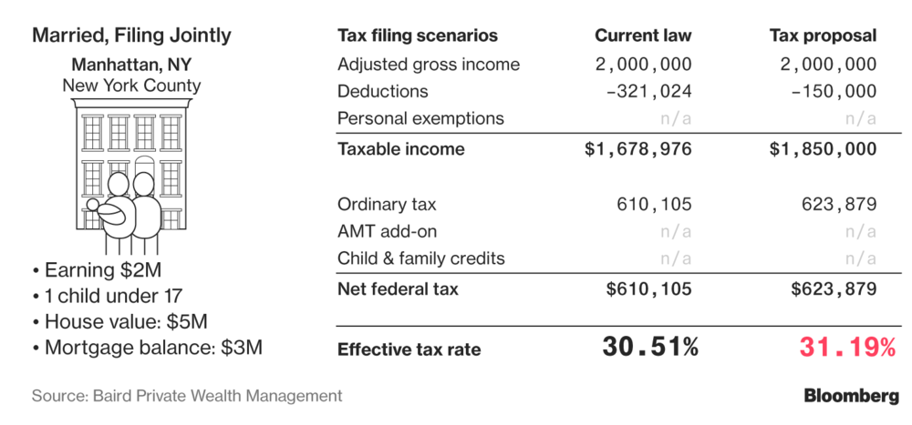

They will pay a bit more next year because they would lose key deductions, especially the ability to put down more than $10,000 in state and local taxes. That offsets a drop in the top marginal tax rate, from 39.6 percent to 37 percent. (The “marginal rate,” the rate paid on any extra dollar earned, is different from the “effective tax rate,” which is the overall, blended rate you pay as different tax rates are levied on your income at different thresholds.)

City taxes for these Manhattan dwellers would work out to almost 4 percent. Combine that with the top federal rate and top state rate, and you get a marginal rate approaching 50 percent.

**The Second-Home Scenario in California**

A married couple has a primary residence in Malibu, California, and a second home in Lake Tahoe. The property tax on the Malibu home is $15,860, and they pay $4,896 on their second home; they deduct a total of $40,000 in mortgage interest for the two homes; and they give $50,000 to charity.

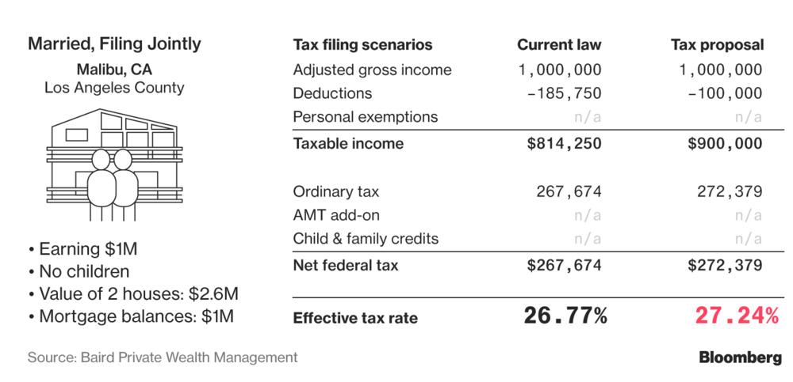

This couple would lose almost $86,000 in deductions under the tax bill. Nonetheless, other changes—especially the drop in the top tax rate—means their effective tax rate creeps up by only 0.5 percentage points.

**The Small Business Owners in Pittsburgh**

This married couple with a small manufacturing business in Pittsburgh has $300,000 in pass-through business income. Their deductible mortgage interest adds up to $6,000; their property tax is $8,600; and they give 5 percent of their income to charity.

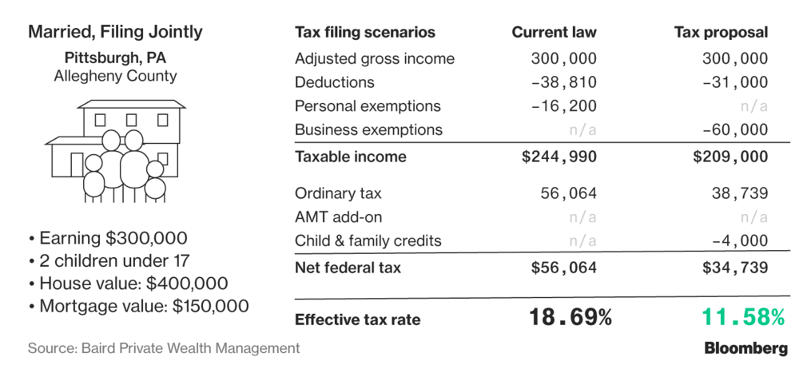

These taxpayers get a big benefit from the new 20 percent deduction aimed at [pass-through business](https://www.bloomberg.com/news/articles/2017-11-03/trump-tax-bill-gives-cuts-in-pass-through-rule-loophole-killers) owners, who pay their business income taxes through their individual tax returns.

**The Suburban Family in Westchester**

A married couple in a New York suburb has estimated state income tax of $17,290; their annual mortgage interest deduction is $14,000; and they pay property tax of $13,750—about the same amount they donate to charity.

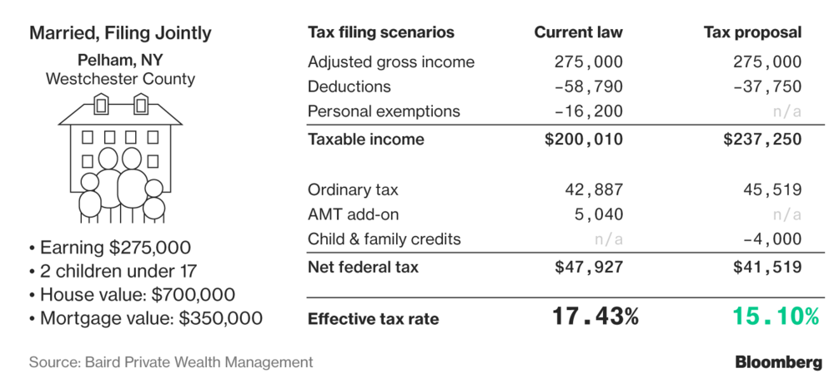

While the bill takes a bite out of this family’s deductions and exemptions, they would benefit from enhanced child tax credits and avoiding the alternative minimum tax, or AMT. (The bill would raise the thresholds at which the AMT applies—until 2026.)

**Single in Manhattan**

This New York renter pays estimated state income tax of $8,148 and gives about $6,500 to charity.

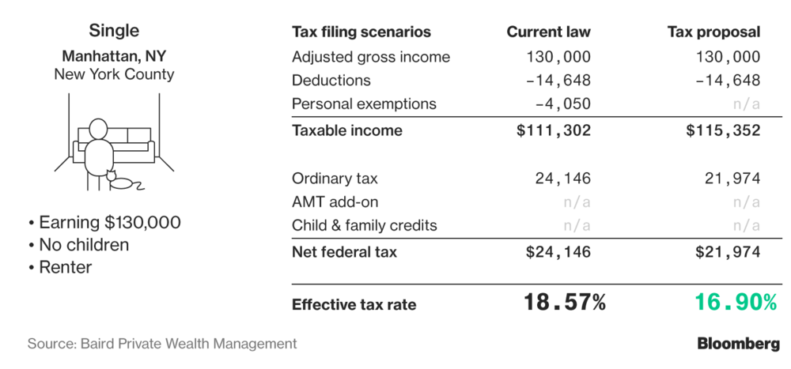

The final tax legislation is more generous to this taxpayer than the bills that originally passed the House and Senate. That’s because it permits the deduction of state and local income taxes up to $10,000. The original proposals scrapped the income tax deduction entirely and allowed only a $10,000 deduction for property taxes, which this renter doesn’t pay.

**Married in Austin**

This young couple rents and has income of $100,000. They give $5,000 a year to charity.

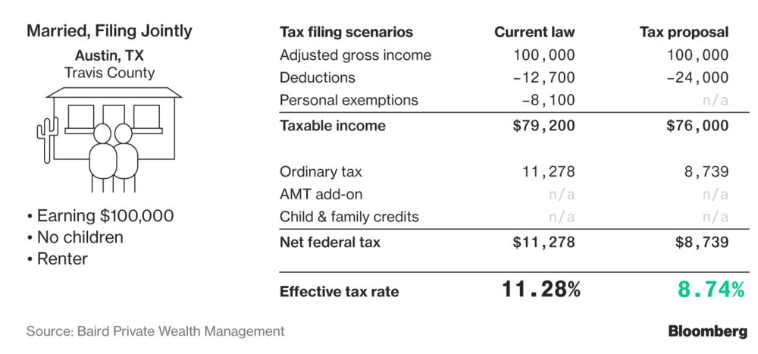

The bill eliminates the personal exemption, an automatic $4,050 deduction for each family member. But for this couple, that loss is offset by rate cuts and a near-doubling of the standard deduction, from $12,700 to $24,000 for married couples.

**Median Income in Oregon**

This Portland, Oregon, couple earns close to the median household income for the U.S. Their property tax bill is $1,688; their deductible mortgage interest is $3,000; and their estimated state income tax is $4,744.

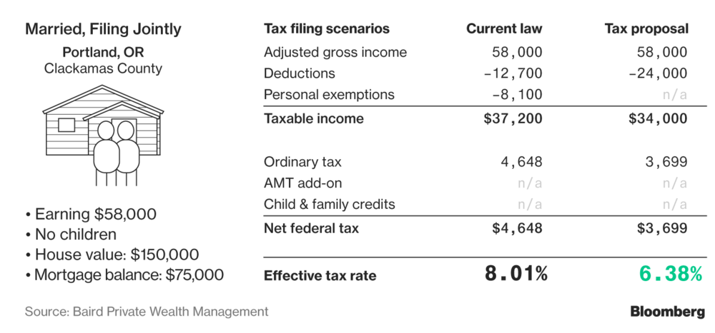

Because this couple has few deductions, they benefit from the higher standard deduction, netting a 2018 tax cut of $949.

**Renting in Milwaukee**

This married couple rents and has an estimated 2017 state income tax bill of $2,104.

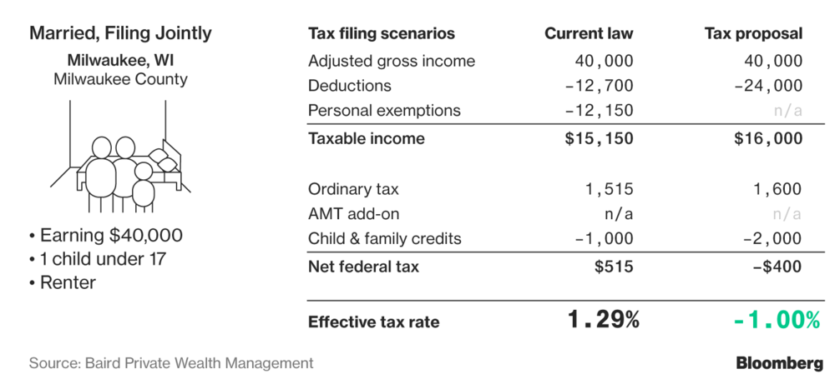

This family ends up with negative income tax rate, because they benefit from the enhanced child tax credits, which are refundable. That means that, subject to limits, low-income taxpayers are able to get larger refunds than they pay in income taxes.

— With assistance by Chloe Whiteaker, and Hannah Recht